5.56:
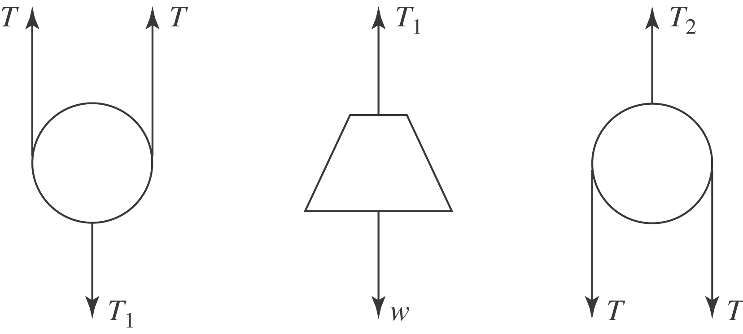

The tension in the lower chain balances the weight and so is equal to w. The lower pulley must have no net force on it, so twice the tension in the rope must be equal to w, and so the tension in the rope is 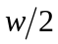. Then, the downward force on the upper pulley due to the rope is also w, and so the upper chain exerts a force w on the upper pulley, and the tension in the upper chain is also w.

